**DAILY ONLINE ACTIVITIES SUMMARY**

|  |  |  |  |  |  |  |
| --- | --- | --- | --- | --- | --- | --- |
| **Date:** | | | **28/05/2020** | **Name:** | **JASLINE SHARON TAURO** | |
| **Sem & Sec** | | | **4th sem, A Section** | **USN:** | **4AL18CS029** | |
| **Online Test Summary** | | | | | | |
| **Subject** | 1. **MICROCONTROLLER AND EMBEDDED SYSTEMS** 2. **ADALITHA KANNADA** | | | | | |
| **Max. Marks** | 1. **20** 2. **50** | | | **Score** | 1. **20** 2. **46** | |
| **Certification Course Summary** | | | | | | |
| **Course** | | | 1. **Introduction to Packet Tracer** 2. **Trailhead Basics** | | | |
| **Certificate Provider** | | 1. **CISCO ACADEMY** 2. **SALES FORCE** | | **Duration:** | | 1. **2 HRS** 2. **2 HRS** |
| **Coding Challenges** | | | | | | |
| **Problem Statement:**   1. C program to find digital root of a number | | | | | | |
| **Status: DONE** | | | | | | |
| **Uploaded the report in GitHub** | | | | **YES** | | |
| **If yes Repository name** | | | | [**https://github.com/jaslinesharontauro/C_Prgms**](https://github.com/jaslinesharontauro/C_Prgms) | | |
| **Uploaded the report in slack** | | | | **YES** | | |

**Online Test Details: (Attach the snapshot and briefly write the report for the same)**

**Certification Course Details: (Attach the snapshot and briefly write the report for the same)**

**Coding Challenges Details: (Attach the snapshot and briefly write the report for the same)**

**1.ONLINE TEST DETAILS:**

**Today we had assessment in the subject MICROCONTROLLER AND EMBEDDED SYSTEMS. It was based on SECOND module of this subject. There were total 20 number of questions of ONE mark each, out of which I scored 20.**

**And also, we had final assessment of the subject ADALITHA KANNADA.There were totally 10 chapters in this subject. The questions were MCQ type. The test was comprised of 50 questions of ONE mark each, out of which I scored 46.**

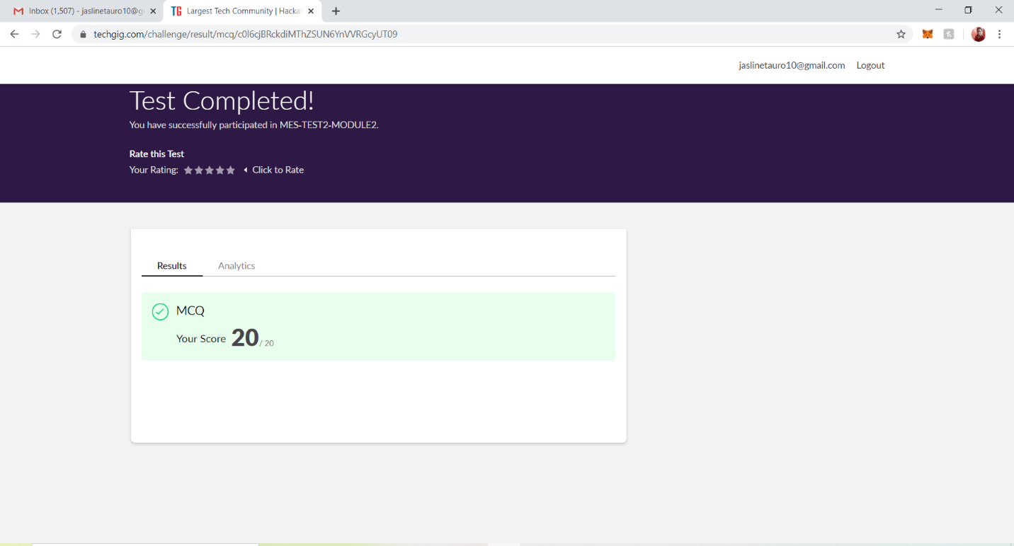

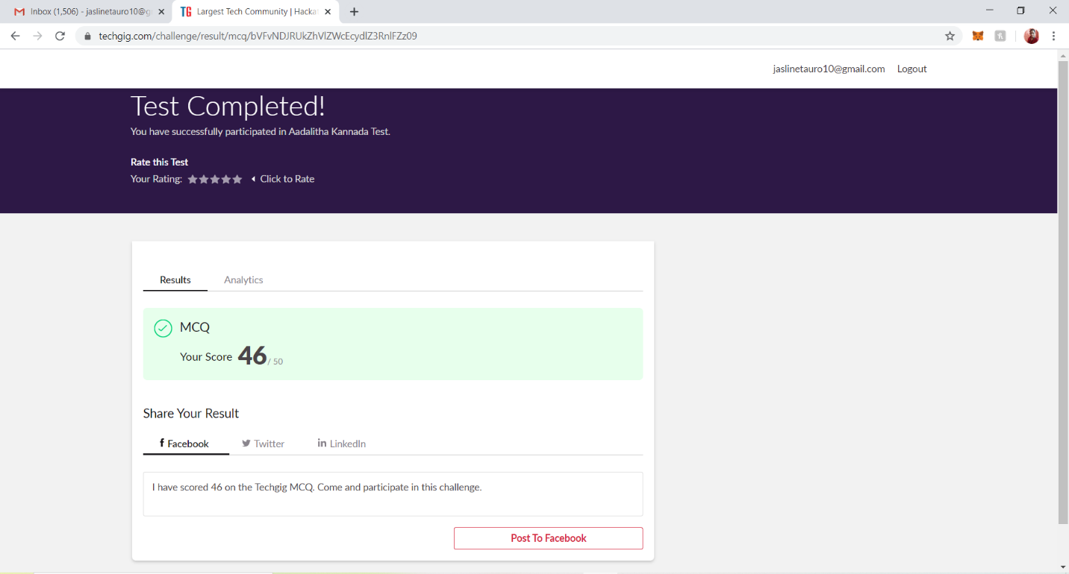

**2.CERTIFICATION COURSE DETAILS**

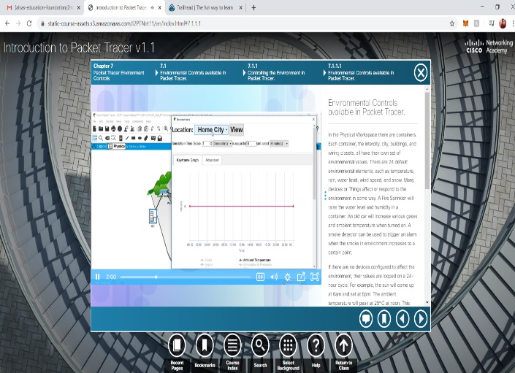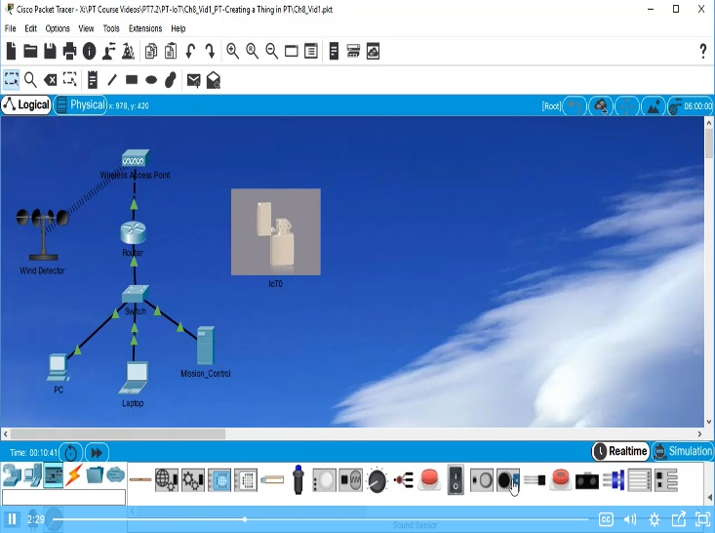I have done certification course on INTODUCTION TO PACKET TRACER. This Introduction to Packet Tracer course is designed for new users of Packet Tracer for self-study and familiarization with the tool used in many Networking Academy courses.

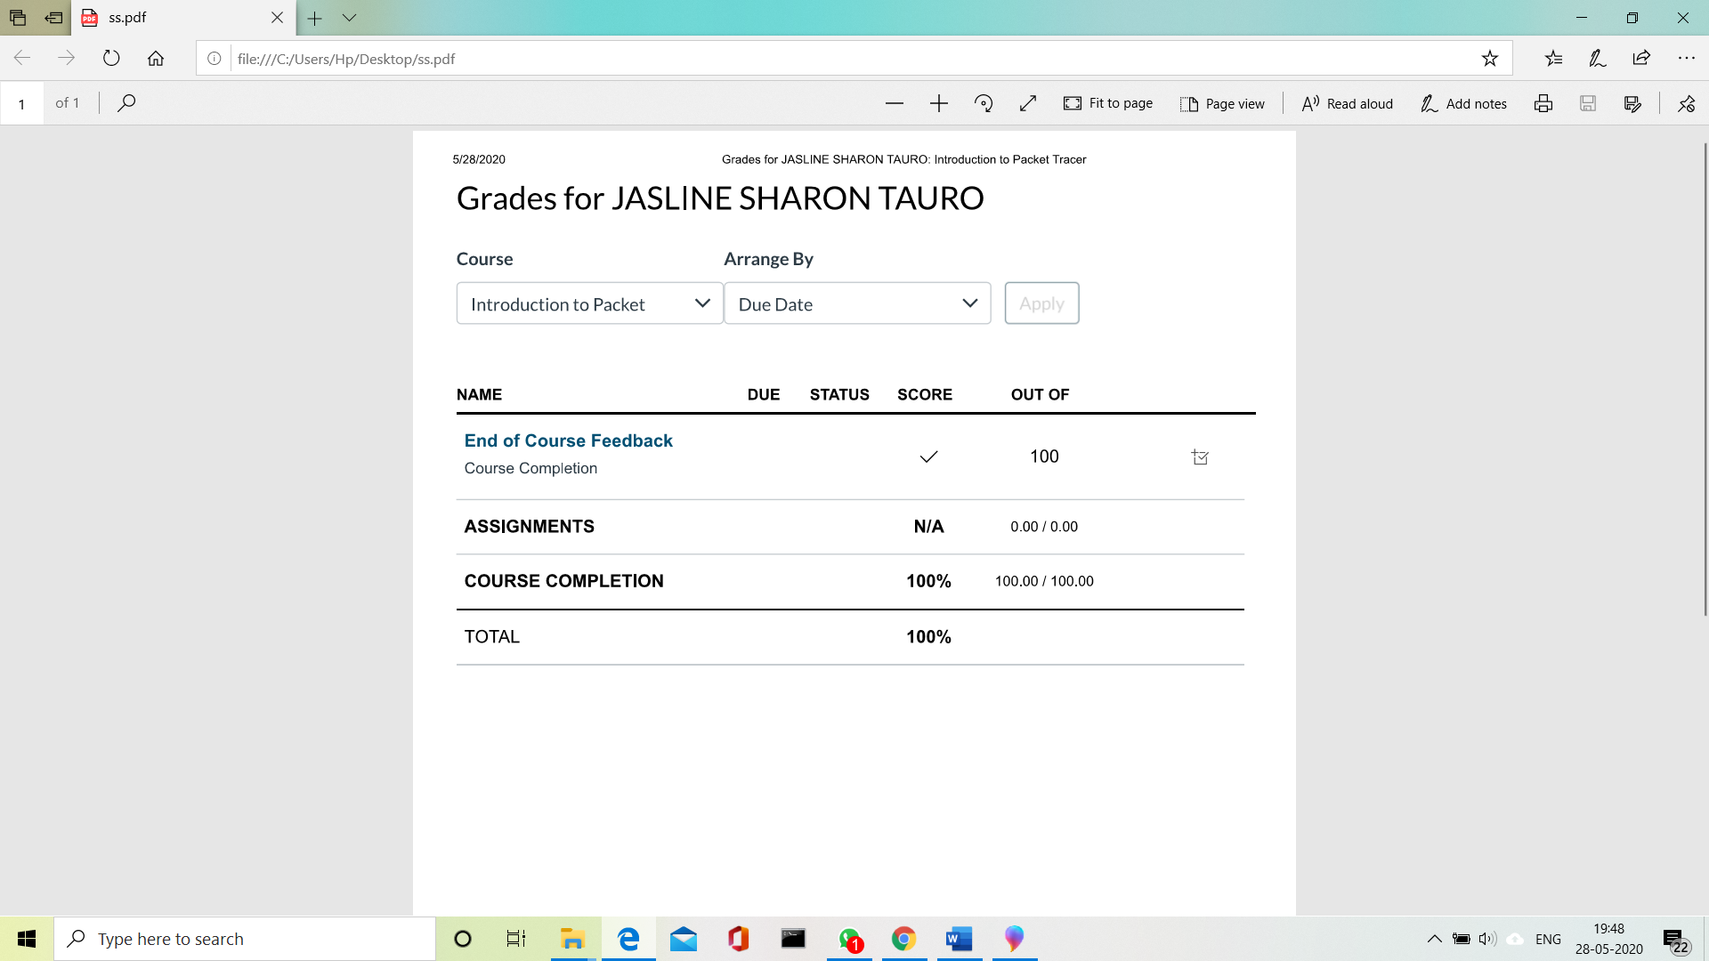

**Today I have started a new course on TRAILHEAD BASICS. Trailhead comprises of** such as modules on [Blockchain Basics](https://trailhead.salesforce.com/content/learn/modules/blockchain-basics) and [European Union Privacy Law Basics](https://trailhead.salesforce.com/modules/european-union-privacy-law-basics), and a trail to help to [Get Started with iOS App Development](https://trailhead.salesforce.com/content/learn/trails/start-ios-appdev).

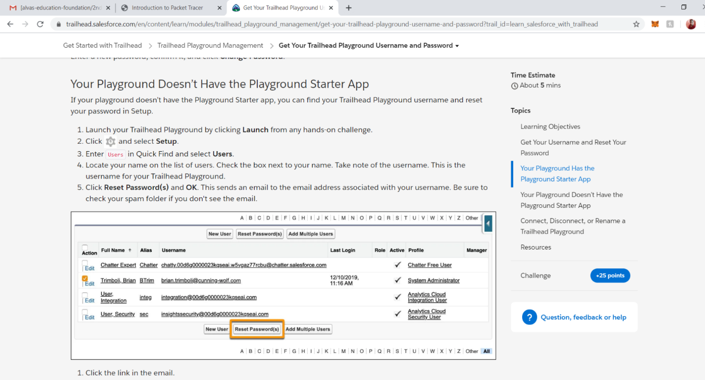

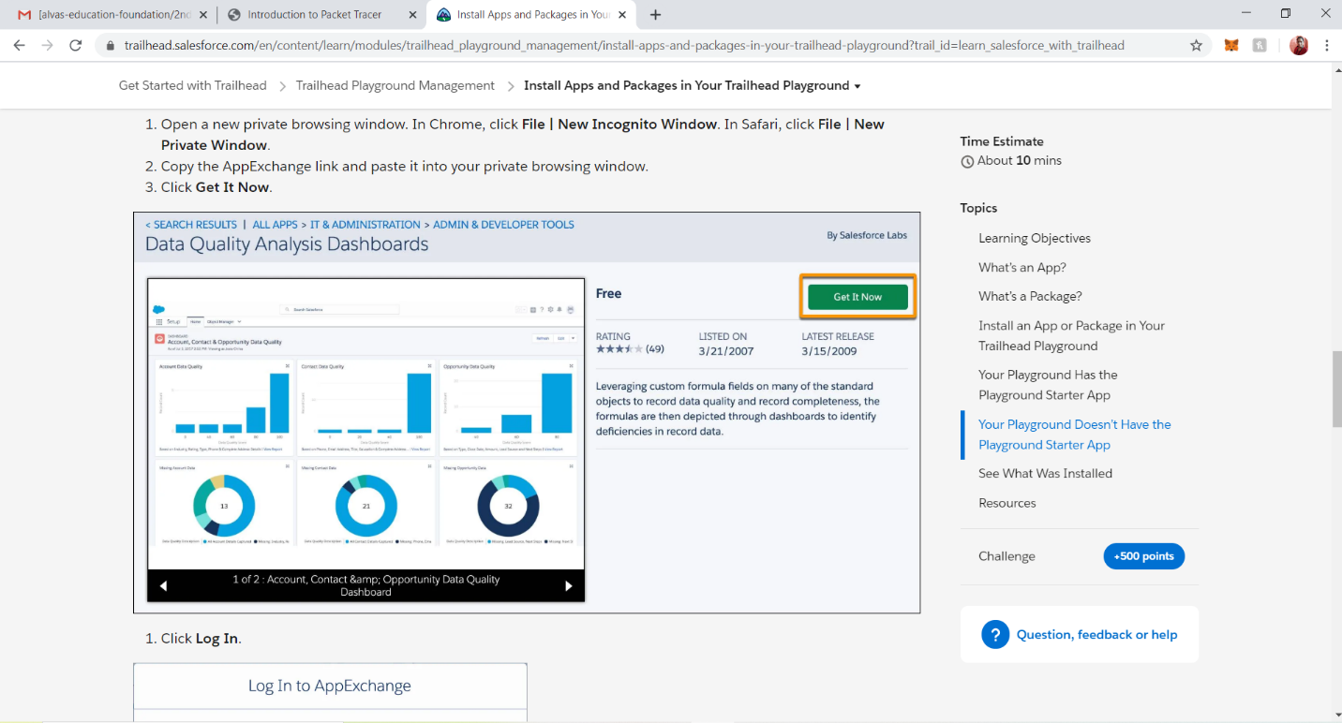

**3.CODING CHALLENGES DETAILS:**

**Problem statement 1:**

C program to find digital root of a number

Description:  
A digital root is the recursive sum of all the digits in a number. Given n, take the sum of the digits of n. If that value has more than one digit, continue reducing in this way until a single-digit number is produced. This is only applicable to the natural numbers.  
digit root (0) = 0

digital root (16)  
=> 1 + 6  
=> 7

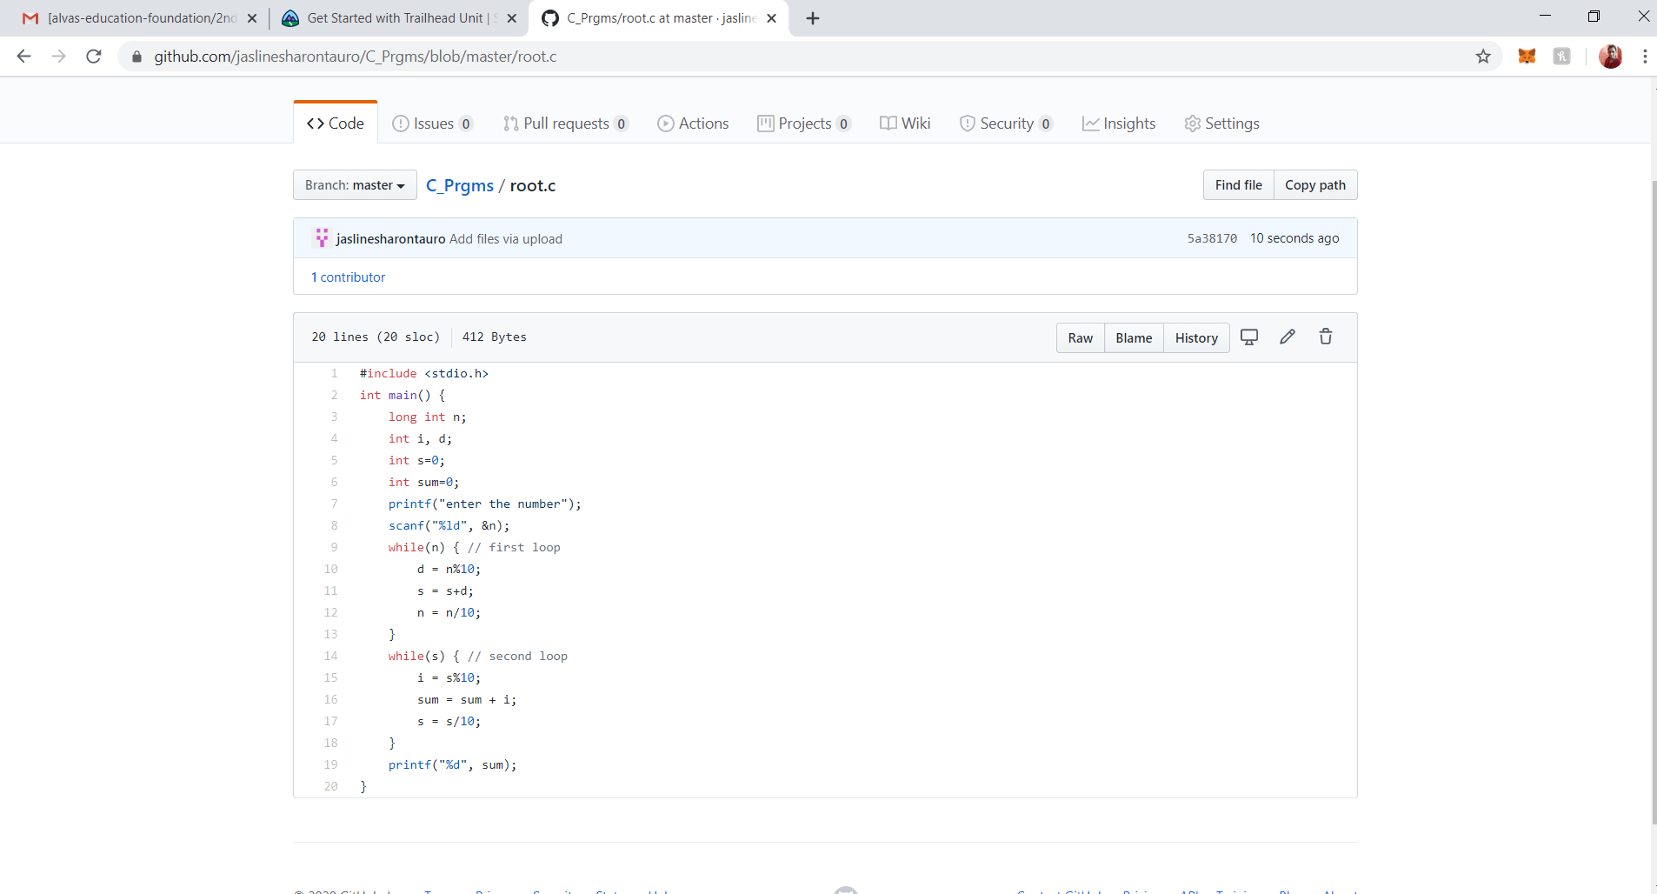digital root (132189)  
=> 1 + 3 + 2 + 1 + 8 + 9  
=> 24 ...  
=> 2 + 4  
=> 6